Chapter 21
Option Valuation
21-1. The current price of Estelle Corporation stock is $25. In each of the next two years, this stock price will either go up by 20% or go down by 20%. The stock pays no dividends. The one-year risk-free interest rate is 6% and will remain constant. Using the Binomial Model, calculate the price of a one-year call option on Estelle stock with a strike price of $25.
In this case, the stock price either rises to S_{u} = 25 × 1.20 = 30 or falls to S_{d} = 25 × 0.80 = 20. The option payoff is therefore either C_{u} = 5 or C_{d} = 0. The replicating portfolio is Δ = (5 − 0)/(30 − 20) = 0.5 and
B = (0 − 20 × 0.5)/1.06 = −9.43.
Therefore, C = 0.5 × 25 − 9.43 = $3.07.
21-2. Using the information in Problem 1, use the Binomial Model to calculate the price of a one year put option on Estelle stock with a strike price of $25.
The parameters are the same as in 21-1, but the payoff of the put is 0 if the stock goes up and 5 if the stock goes down. Therefore, the replicating portfolio is
Δ = (0 − 5)/(30 − 20) = –0.5 and B = (5 − 20×(–0.5))/1.06 = 14.15.
Therefore, P = –0.5 × 25 + 14.15 = $1.65.
21-3. The current price of Natasha Corporation stock is $6. In each of the next two years, this stock price can either go up by $2.50 or go down by $2. The stock pays no dividends. The one-year risk-free interest rate is 3% and will remain constant. Using the Binomial Model, calculate the price of a two-year call option on Natasha stock with a strike price of $7.
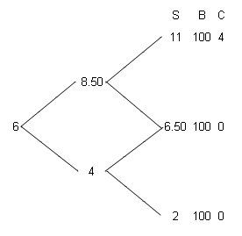
Up state at time 1: Δ = (4 − 0)/(11 − 6.50) = 0.889, B = (0 − 6.50×0.889)/1.03 = −5.61, therefore C_{u} = 0.889 × 8.50 − 5.61 = $1.95.
In the down state at time 1 the option is worth nothing. The call option at time 0 is therefore equivalent to the replicating portfolio Δ = (1.95 − 0)/(8.50 − 4) = 0.433, B = (0 − 4 × 0.433)/1.03 = −1.68 and so, by the Law of One Price, the initial option price is 0.433 × 6 − 1.68 = $0.92.
21-4. Using the information in Problem 3, use the Binomial Model to calculate the price of a two-year European put option on Natasha stock with a strike price of $7.
If the stock goes up twice, the put is worth zero. If the stock ends up at $6.50, the put is worth $0.50; if the stock goes down twice, the put is worth $5. Given these final values, we can calculate the value of the put at earlier dates using the binomial model.
Up state at time 1: Δ = (0 − 0.50)/(11 – 6.50) = –0.111 and B = (0.50 − 6.50 × (–0.111))/1.03 = 1.19.
Therefore, P_{u} = –0.111 × 8.50 + 1.19 = $0.25.
Down state at time 1: Δ = (0.50 − 5)/(6.50 – 2) = –1 and B = (5 − 2×(–1))/1.03 = 6.80
Therefore, P_{d} = –1 × 4 + 6.80 = $2.80.
Time 0: Δ = (0.25 − 2.80)/(8.50 – 4) = –0.567 and B = (2.80 − 4 × (–0.567))/1.03 = 4.92
Therefore, P_{d} = –0.567 × 6 + 4.92 = $1.52.
21-5. Suppose the option in Example 21.1 actually sold in the market for $8. Describe a trading strategy that yields arbitrage profits.
In Example 21.1, the theoretical put price is $3.30. If it actually sells for a higher price, it is overvalued, and we can sell it and buy the replicating portfolio to earn an arbitrage profit. This means that at t = 0, you will sell the put, short 0.3333 shares of stock, and invest $23.30 in Treasury Bills.
Following this strategy, you will earn the put price less (60 × (–0.3333) + 23.30) = $3.30 upfront.
Then, if the stock goes up, our portfolio of the put, shares, and borrowing is worth $0 – 0.3333 × 72 + 23.30 × 1.03 = $0. If it goes down, our portfolio is worth –$6 – 0.3333 × $54 + 23.30 × 1.03 = $0, so that at maturity, the payoff of the option and the value of the replicating portfolio cancel out.
(Note that this is not the only arbitrage strategy one can follow—e.g., we could invest more in T-Bills initially—but it is the strategy that generates the most cash upfront without any risk of loss in the future.)
21-6. Suppose the option in Example 21.2 actually sold today for $5. You do not know what the option will trade for next period. Describe a trading strategy that will yield arbitrage profits.
In Example 21.2, the theoretical put price is $8.68. If it actually sells for $5, it is underpriced, which means we buy it and sell the replicating portfolio to earn an arbitrage profit. This means that at t = 0, you will buy the $5 put, buy 0.6633 shares of stock, and borrow $41.84.
Following this strategy, you will end up with $41.84 – 0.6633 × 50 – 5 = $3.68 upfront.
At t = 1, you rebalance that portfolio according to the new and B:
If the stock goes up at date 1: we reduce our stock holdings to 0.3333 shares, using the proceeds to reduce our debt to 41.84 × 1.03 – (0.6633 – 0.3333) × $60 = $23.30. Then, if the stock goes up again, our portfolio of the put, shares, and borrowing is worth $0 + 0.3333 × 72 – 23.30 × 1.03 = $0. If it goes down, our portfolio is worth $6 + 0.3333 × $54 – 23.30 × 1.03 = $0.
If the stock goes down at date 1: we increase our stock holdings to 1 share, and increase our debt to 41.84 × 1.03 + (1 – 0.6633) × $45 = $58.25. Then, if the stock goes up, our portfolio of the put, shares, and borrowing is worth $6 + 1 × 54 – 58.25 × 1.03 = $0. If it goes down, our portfolio is worth $19.50 + 1 × 40.50 – 58.25 × 1.03 = $0.
Thus, we have made a profit of $3.68 upfront, with a zero payoff no matter what happens in the future.
21-7. Eagletron’s current stock price is $10. Suppose that over the current year, the stock price will either increase by 100% or decrease by 50%. Also, the risk-free rate is 25% (EAR).
a. What is the value today of a one-year at-the-money European put option on Eagletron stock?
b. What is the value today of a one-year European put option on Eagletron stock with a strike price of $20?
c. Suppose the put options in parts a and b could either be exercised immediately, or in one year. What would their values be in this case?
a. P_{u} = 0, P_{d} = 5, delta = (0 – 5)/(20 – 5) = –1/3, B = (5 – 5(–1/3))/1.25 = 5.33
P = –1/3(10) + 5.33 = $2.00
b. The payoffs are P_{u} = 0, P_{d} = 15. Because these payoffs are three times the payoffs in (a), the put must be worth 3 × $2 = $6.
c. We can exercise the put immediately and get its intrinsic value. In (a), intrinsic value = 0, so not relevant, value is still $2
In (b) intrinsic value = 20 – 10 = $10, so it is better to exercise now → value is $10 (not $6).
21-8. What is the highest possible value for the delta of a call option? What is the lowest possible value? (Hint: See Figure 21.1.)
Delta <= 1, Delta >= 0
21-9. Hema Corp. is an all equity firm with a current market value of $1000 million (i.e., $1 billion), and will be worth $900 million or $1400 million in one year. The risk-free interest rate is 5%. Suppose Hema Corp. issues zero-coupon, one-year debt with a face value of $1050 million, and uses the proceeds to pay a special dividend to shareholders. Assuming perfect capital markets, use the binomial model to answer the following:
a. What are the payoffs of the firm’s debt in one year?
b. What is the value today of the debt today?
c. What is the yield on the debt?
d. Using Modigliani-Miller, what is the value of Hema’s equity before the dividend is paid? What is the value of equity just after the dividend is paid?
e. Show that the ex-dividend value of Hema’s equity is consistent with the binomial model. What is the Δ of the equity, when viewed as a call option on the firm’s assets?
a. Either 1050 (if the firm does well) or 900 (if the firm does poorly and defaults).
b. We can use the binomial model: delta = (1,050 – 900)/(1,400 – 900) = 0.3, B = (900 – 900(0.3))/(1.05) = 600, Debt value = 0.3(1,000) + 600 = 900.
c. 1,050/900 = 16.67%
d. MM: initial value should not change = $1,000. Subtract dividend of $900 (debt value) to determine ex-div value = $100.
e. Equity payoffs are 1,400 – 1,050 = 350 or 0.
Delta = (350 – 0)/(1,400 – 900) = 0.70
B = (0 – 900(0.7))/1.05 = –600
Equity Value = 0.7(1,000) – 600 = 100
21-10. Consider the setting of Problem 9. Suppose that in the event Hema Corp. defaults, $90 million of its value will be lost to bankruptcy costs. Assume there are no other market imperfections.
a. What is the present value of these bankruptcy costs, and what is their delta with respect to the firm’s assets?
b. In this case, what is the value and yield of Hema’s debt?
c. In this case, what is the value of Hema’s equity before the dividend is paid? What is the value of equity just after the dividend is paid?
a. Bankruptcy costs are 0 or 90.
Delta = (0 – 90)/(1,400 – 900) = –0.18
B = (90 – 900(–0.18))/1.05 = 240
BC value = –0.18(1,000) + 240 = $60 million
b. Debt value = $900 less BC = 900 – 60 = $840
Yield = 1,050/840 – 1 = 25%
c. On announcement, equity value declines by BC = $1,000 – 60 = $940. Subtract dividend of $840 (debt value) to determine ex-div value = $100 (Note this ex-div value is the same as in Problem 9 because equity holders have the same final payoffs.)
21-11. Roslin Robotics stock has a volatility of 30% and a current stock price of $60 per share. Roslin pays no dividends. The risk-free interest is 5%. Determine the Black-Scholes value of a one-year, at-the-money call option on Roslin stock.
BS value = $8.50
21-12. Rebecca is interested in purchasing a European call on a hot new stock, Up, Inc. The call has a strike price of $100 and expires in 90 days. The current price of Up stock is $120, and the stock has a standard deviation of 40% per year. The risk-free interest rate is 6.18% per year.
a. Using the Black-Scholes formula, compute the price of the call.
b. Use put-call parity to compute the price of the put with the same strike and expiration date.
a. Using the Black-Sholes formula:
PV(K) = 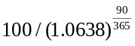 = 98.487, 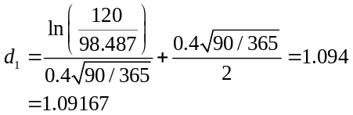
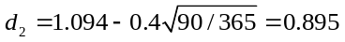
b. Using put-call parity:
21-13. Using the data in Table 21.1, compare the price on July 24, 2009, of the following options on JetBlue stock to the price predicted by the Black-Scholes formula. Assume that the standard deviation of JetBlue stock is 65% per year and that the short-term risk-free rate of interest is 1% per year.
a. December 2009 call option with a $5 strike price
b. December 2009 put option with a $6 strike price
c. March 2010 put option with a $7 strike price
The January contract expires on the third Friday of January (20th); there are 45 days left until expiration.
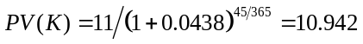, 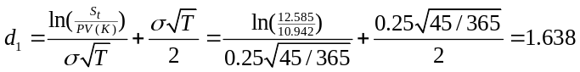
Substituting d₁ and d₂ into the Black-Scholes formula gives:
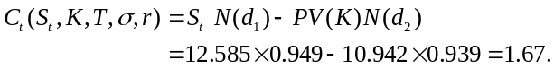
This value is between the bid and ask prices of $1.65 and $1.75.
a. BS price = $0.85
b. BS price = $1.45
c. BS price = $2.42
21-14. Using the market data in Figure 20.10 and a risk-free rate of 0.25% per annum, calculate the implied volatility of Google stock in September 2012, using the bid price of the 700 January 2014 call option.
The bid and ask prices of the call are $87.60 and 91.00, the time to expiration is approximately 1.36 years (September 10, 2012 to Jan 18, 2014 = 20 + 92 +365 + 18 = 495 days), and the price of the stock is $700.77.
With PV(K) = 700/(1+0.0025)^{1.36} = 697.63,
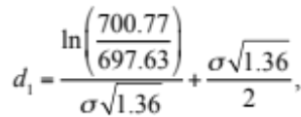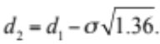
The Black-Scholes formula, Eq. 21.7, implies: 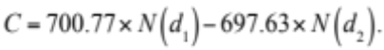
You can verify that C is between the bid and ask prices for the call option when 27%.(You can find the σ by guessing or using a calculator or spreadsheet program.) Thus, the implied volatility for Google derived from this call option (using the bid price) is about 26.6%.
21-15. Using the implied volatility you calculated in Problem 14, and the information in that problem, use the Black-Scholes option pricing formula to calculate the value of the 340 January 2011 call option.
Implied volatility is 27.1% from Problem 21.9. The strike price = 750, current stock price is 700.77, and the risk-free rate is 0.25%, with a time to maturity of 1.36 years.
The Black-Scholes formula gives:
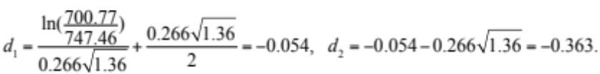
Therefore,
Note that the call price is in the range of the quotes provided in Table 20.10.
21-16. Plot the value of a two-year European put option with a strike price of $20 on World Wide Plants as a function of the stock price. Recall that World Wide Plants has a constant dividend yield of 5% per year and that its volatility is 20% per year. The two-year risk-free rate of interest is 4%. Explain why there is a region where the option trades for less than its intrinsic value.
The price of the put is given by the standard Black-Scholes equation for puts, but with the stock price replaced everywhere with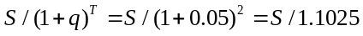. Given PV(K) = 20/1.04² = 18.491. Therefore,
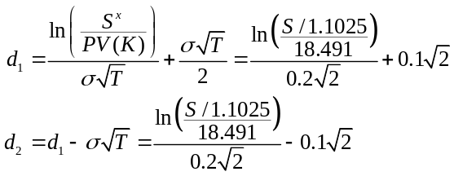
so, the value of the put option given current stock price S is
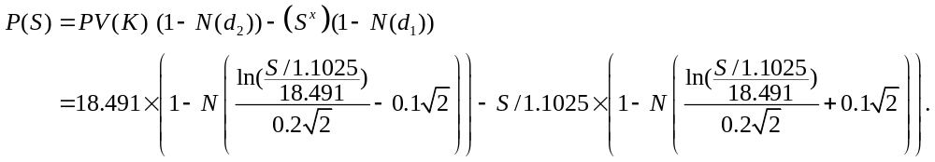
Plotting this function (the curved line below) gives:
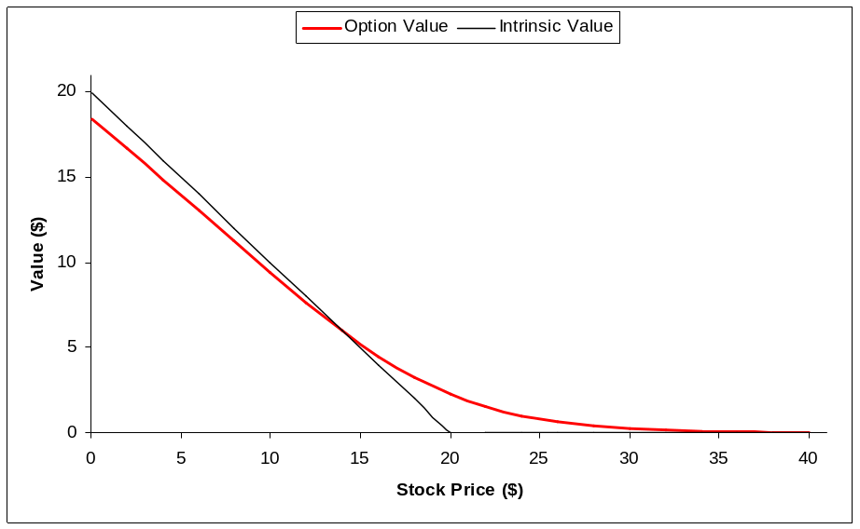
Notice that when the put is deep in the money it is worth less than its intrinsic value. In this case the time value is negative because the size of the discount on a two year zero-coupon bond is larger than the value of the dividends and the call option, implying a negative time value for the option.
21-17. Consider the at-the-money call option on Roslin Robotics evaluated in Problem 11. Suppose the call option is not available for trade in the market. You would like to replicate a long position in 1000 call options.
a. What portfolio should you hold today?
b. Suppose you purchase the portfolio in part a. If Roslin stock goes up in value to $62 per share today, what is the value of this portfolio now? If the call option were available for trade, what would be the difference in value between the call option and the portfolio (expressed as percent of the value of the call)?
c. After the stock price change in part b, how should you adjust your portfolio to continue to replicate the options?
a. Delta = N(d1) = N(0.312634) = 0.6227, so purchase 623 shares.
B = –28.859, so borrow $28,859.
Cost = 622.27 × 60 – 28,859 = $8,504
b. Portfolio = 622.27 × 62 – 28,859 = 9,749
Call = 9,790
Difference = (9,749 – 9,790)/9,790 = –0.42%
c. Delta = 0.663
Increase shares to 663.
Borrow additional (663 – 623) × 62 = $2,526.
21-18. Consider again the at-the-money call option on Roslin Robotics evaluated in Problem 11. What is the impact on the value of this call option of each of the following changes (evaluated separately)?
a. The stock price increases by $1 to $61.
b. The volatility of the stock goes up by 1% to 31%.
c. Interest rates go up by 1% to 6%.
d. One month elapses, with no other change.
e. The firm announces a $1 dividend, paid immediately.
Original BS price = $8.50
a. BS price = $9.14
b. BS price = $8.73
c. BS price = $8.78
d. BS price = $8.09
e. Ex-div stock price = $59, BS price = $7.89
21-19. Harbin Manufacturing has 10 million shares outstanding with a current share price of $20 per share. In one year, the share price is equally likely to be $30 or $18. The risk-free interest rate is 5%.
a. What is the expected return on Harbin stock?
b. What is the risk neutral probability that Harbin’s stock price will increase?
a. 0.5(30+18)/20 – 1 = 20%
b. 25%
21-20. Using the information on Harbin Manufacturing in Problem 19, answer the following:
a. Using the risk neutral probabilities, what is the value of a one-year call option on Harbin stock with a strike price of $25?
b. What is the expected return of the call option?
c. Using the risk neutral probabilities, what is the value of a one-year put option on Harbin stock with a strike price of $25?
d. What is the expected return of the put option?
a. 25% × (30 – 25)/1.05 = $1.19
b. 50% × (5)/1.19 – 1 = 110%
c. 75% × (25 – 18)/1.05 = $5
d. 50% × (7)/5 – 1 = –30%
21-21. Using the information in Problem 1, calculate the risk-neutral probabilities. Then use them to price the option.
The risk neutral probabilities can be calculated using:
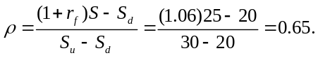
Using these probabilities the price of the option is
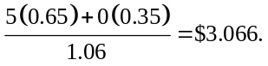
21-22. Using the information in Problem 3, calculate the risk-neutral probabilities. Then use them to price the option.
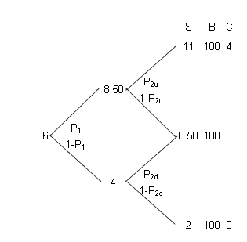
The risk neutral probabilities are
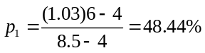
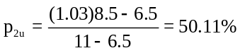
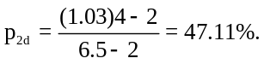

The value of the call is therefore:
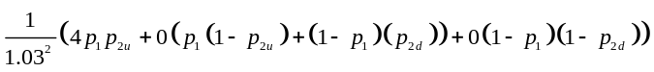
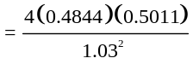 = $0.9153.
21-23. Explain the difference between the risk-neutral and actual probabilities. In which states is one higher than the other? Why?
Actual probabilities are the probabilities with which an event will happen. Risk-neutral probabilities are the probabilities of an event happening in a world where investors are risk-neutral. Thus, risk-neutral probabilities are a construction and do not reflect reality. Assuming that investors are risk-averse, risk-neutral probabilities are lower in good states and larger in bad states. This has to be the case because if investors were risk-neutral, then the expected returns are the risk-free rate, whereas risk-averse demand higher returns. And given the same payoffs, a higher expected return implies good states are more likely.
21-24. Explain why risk-neutral probabilities can be used to price derivative securities in a world where investors are risk averse.
Risk neutral probabilities can be used to price derivative securities because the pricing of derivatives only depends on the characteristics of the underlying asset. By construction, the value of the underlying asset can be calculated using risk-neutral probabilities and therefore the value of the call will depend on these probabilities. Risk-neutral probabilities are the easiest probabilities to work with, given that they simplify the calculations, and that is why we use them.
21-25. Calculate the beta of the January 2010 $9 call option on JetBlue listed in Table 21.1. Assume that the volatility of JetBlue is 65% per year and its beta is 0.85. The short-term risk-free rate of interest is 1% per year. What is the option’s leverage ratio?
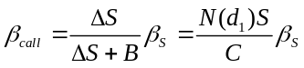
Call option: 175 days to maturity, S = 5.035, K = 9, = 65%,
21-26. Consider the March 2010 $5 put option on JetBlue listed in Table 21.1. Assume that the volatility of JetBlue is 65% per year and its beta is 0.85. The short-term risk-free rate of interest is 1% per year.
a. What is the put option’s leverage ratio?
b. What is the beta of the put option?
c. If the expected risk premium of the market is 6%, what is the expected return of the put option based on the CAPM?
d. Given its expected return, why would an investor buy a put option?
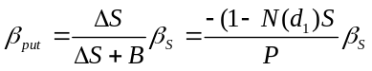
Put option: 238 days to maturity, S = 5.035, K = 5, = 65%, 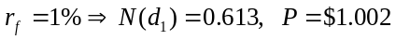
a. 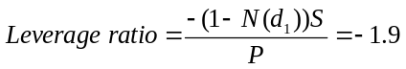
b. 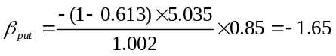
c.
d. An investor would buy a put option given a negative expected return to act as a hedge against losses. The negative beta implies the return will move inversely to the market. Giving good returns when times are bad (when positive returns are the most valuable).
21-27. Return to Example 20.10, in which Google was contemplating issuing zero-coupon debt due in 18 months with a face value of $96 billion, and using the proceeds to pay a special dividend. Google currently has a market value of $135.1 billion and the risk-free rate is 1%. Using the market data in Figure 20.10, answer the following:
a. If Google’s current equity beta is 1.45, estimate Google’s equity beta after the debt is issued.
b. Estimate the beta of the new debt.
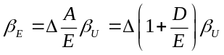
a. We want the 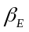following the debt issuance:
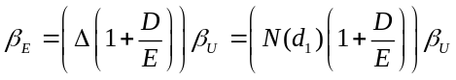
We have: S = 229.2, K = 163.5, r = 0.25%, T = 1.33 years, 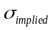= 26.6% from problem 21.14
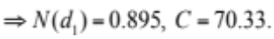
So Google’s equity beta would be 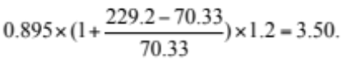
b. 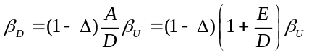
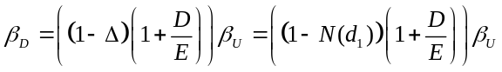
So Google’s debt beta would be 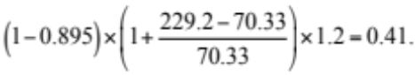
21-28. You would like to know the unlevered beta of Schwartz Industries (SI). SI’s value of outstanding equity is $400 million, and you have estimated its beta to be 1.2. SI has four-year zero-coupon debt outstanding with a face value of $100 million that currently trades for $75 million. SI pays no dividends and reinvests all of its earnings. The four-year risk-free rate of interest is currently 5.13%. Use the Black-Scholes formula to estimate the unlevered beta of the firm.
The equity can be interpreted as a four-year call option on the firm's assets with a strike price of $100 million. The current market value of assets is 400 + 75 = $475 million.
Using the Black-Scholes formula, we can get the implied volatility of assets: Call option value = 400, K = 100, S = 475, T = 4, r = 0.0513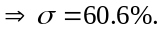
Using the volatility:
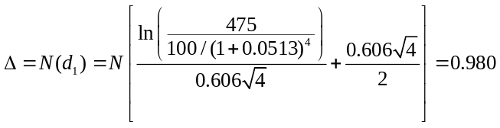
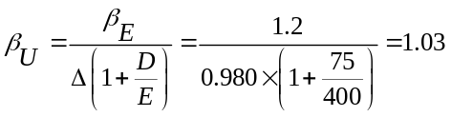
a: D = 900/1.09⁵ = 585. S = D + E = 585 + 20 × 25 = 1085, r_{f} = 5%, K = 900, T = 5
Vol = 35%
b: B_d D/B_e E = (1 – delta)/delta = (1 – 0.827)/0.827 = 0.209
c: Asset value could fall to 1008, and with volatility of 45%, equity call option is worth 500. Thus, NPV could be 1,008 – 1,085 = –77 million, and equity holders still gain!
21-29. The J. Miles Corp. has 25 million shares outstanding with a share price of $20 per share. Miles also has outstanding zero-coupon debt with a 5-year maturity, a face value of $900 million, and a yield to maturity of 9%. The risk-free interest rate is 5%.
a. What is the implied volatility of Miles’ assets?
b. What is the minimum profitability index required for equity holders to gain by funding a new investment that does not change the volatility of the Miles’ assets?
c. Suppose Miles is considering investing cash on hand in a new investment that will increase the volatility of its assets by 10%. What is the minimum NPV such that this investment will increase the value of Miles’ shares?
a: Miles’ equity can be viewed as a call option on Miles’ assets with a strike price of 900, five years to maturity, and a market value of $20/share × 25 million shares = $500 million. The market value of Miles’ debt is D = 900/1.09⁵ = 585. Using Black-Scholes with parameters S = D + E = 585 + 500 = 1085, r_{f} = 5%, K = 900, T = 5, we find an implied volatility of Mile’s assets of 35%.
b: We can use Black-Scholes to calculate the delta of the equity call option in (a) to be Δ = 0.827. Then, the profitability index must exceed (see Example 21.11 and also Eq. 16.2) β_{d} D/(β_{e} E) = (1 – Δ)/ Δ = (1 – .827)/.827 = 0.209. (To understand this, note that a $1 investment by equity holders with and NPV of $0.209 will increase the value of the assets by $1.209, and so increase the value of equity by approximately 0.827 × 1.209 = $1.)
c: Asset value could fall to 1,009, and with volatility of 45%, equity call option has value just over 500.
Thus, NPV could be 1,009 – 1,085 = – 76 million, and equity holders still gain!

